HS150
Handheld Infrared Counterfeit Detector
User Manual

Ⅰ. Device feature
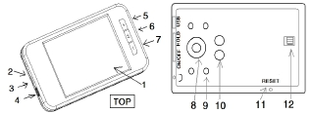

1.Touch Screen; 2. Power Switch;3. UV Switch; 4. DC IN;5. Zoom In;6. Photograph;7. ZoomOut;
8. Camera;9. IR;10.UV(Optional);11. Reset;12.SD Card(largest support 2GB).

Ⅱ. Operation instructions
1.Take the detector and press Power Button for some seconds: After the Boot initialization
about 8 seconds the screen will light and start work.
2. Keep about 10 cm between the camera and currency, and take the camera to the center
of the currency to observe the IR image and the device can be moved up or down for best results ( as show)..
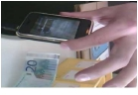
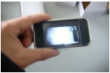

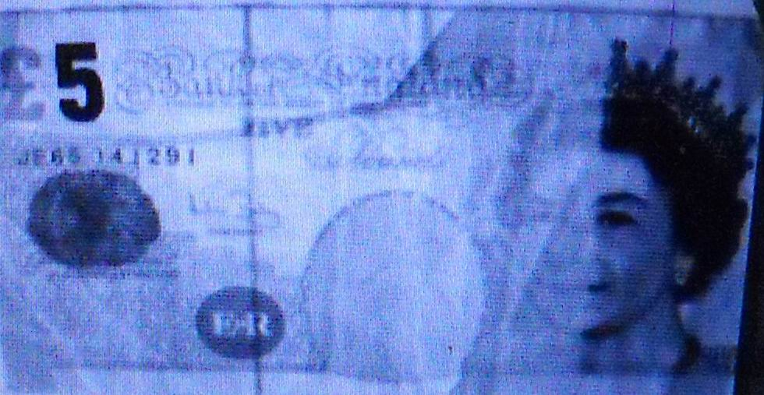
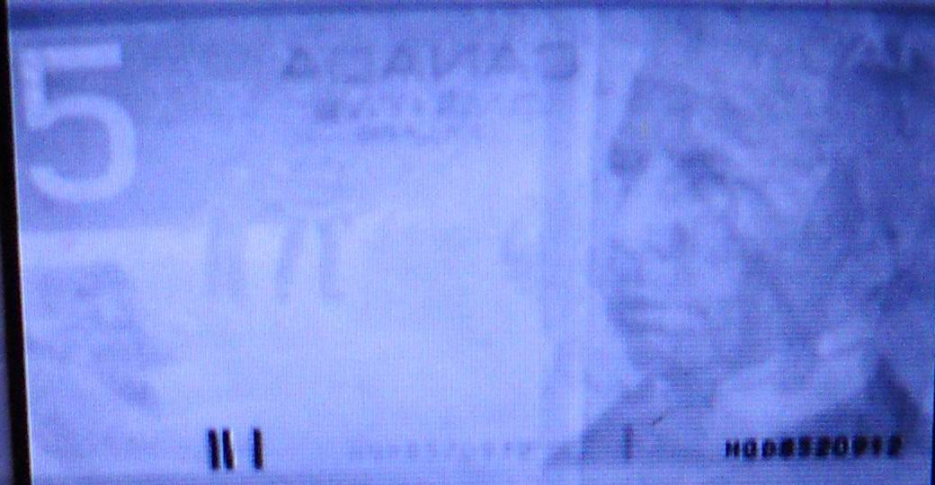
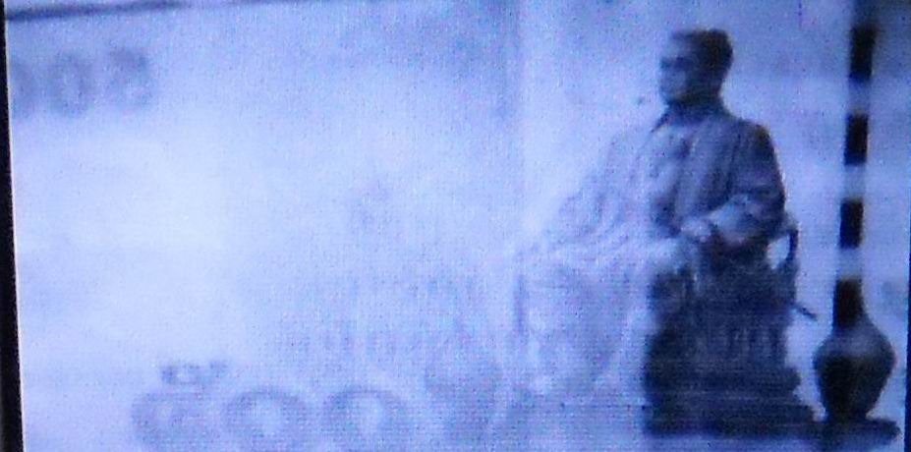
3.The IR image for main currencies:
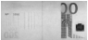

EURO（200） USD（100） GBP（5） CAD（5） THB（100）
4. The user can compare the IR image in the screen to differentiate the fake notes.
5. Secure IR–marks printing is one of the basic methods of banknote protection against counterfeiting, applied to the most of world currencies. IR-marks are widely used for protection of securities, passports, certificates, duty stamps and other security printing documents.
6 .Switch on the UV Led to observe the Fluorescence. ( This function is current consuming, please
switch off after using it.)
7. The Built-in storage chip can save 50 picture, the user can use SD card (2GB) to take
and save more pictures. And the detector can connect with the PC to observe the pictures.
8. The detector can connect with PC or use AC Adapter for battery charging

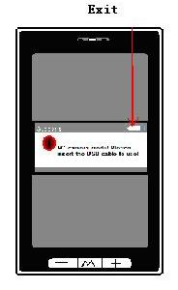
Ⅲ. the icons shown on screen
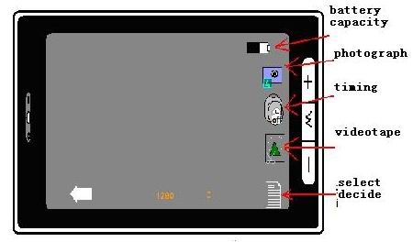

Ⅳ.Technical specifications:
Sensor: IR + CMOS Sensor, UV LED(Optional)
Camera Lens: IR camera
Display: HD 2.8” TFT Touch Screen
Standard Observation: The height for object distance is 10cm, the range of display window is
13cm × 10cm.
Power Supply: AC100-240 or Lithium 3.7V or USB; Battery inside life ability> 150 Min
Dimensions: 92X54X15mm
Net Weight: 65g

