HS110
Spectral Luminescence Magnifiers
user's manual

Ⅰ. Device feature
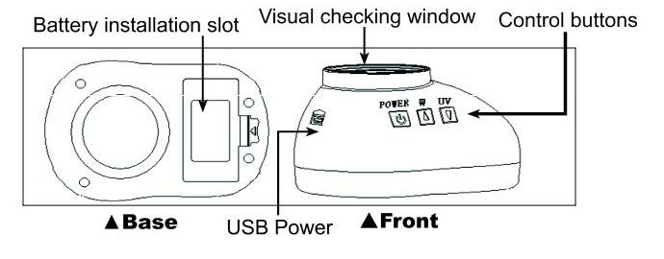

Ⅱ. Operation instructions

User places the HS110 on the object to be checked, aim the visual checking window at the checking spot, press the function button choosing the item.
Power button: Power switch (Press the button for around 2 seconds to turn the power off), clicking the button will lead 90°intercrossed white light or automatic shifting
White light button: Diffuse white light, white side light.
UV light button: Long wave UV (UVA365nm), short wave UV(UVC254), 980nm laser.
Visual checking: Keep about 20cm between eyes and the checking window for best results.
Battery: Please use three AAA batterys, rechargeable battery recommended.
Safety: The fluorescent light (254nm) is extremely harmful for eyes. When the fluorescent light is on, never look from the bottom. Don’t touch it either. The short wave UV will switch off automatically 1minute after start up .
Please note: The HS110 can be equipped with other matching SJY equipments by the USB port.

Ⅲ. Technical specifications

Light sources: Diffuse white light, white side light, 90°intercrossed white light, long wave UVA, short wave UVC, 980nm laser.
Lens: Diameter 30mm, 10×magnification.
Size: 95×65×52 mm
Net weight: 55g
Power: 3AAA or USB 5V ＜400A

＊Turn back

HS11 Series Light Sources Equipping

 | White | UVA(365nm) | UVC(254nm) | Anti-stokes
HS110 | ● | ●
HS111 | ● | ● | ●
HS112 | ● | ● |  | ●
HS113 | ● | ● | ● | ●

